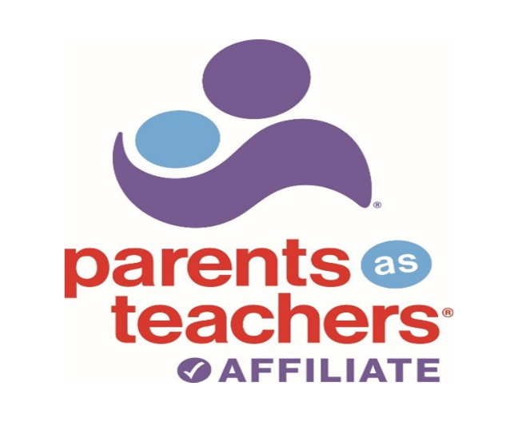

**WYCRP-Parents as Teachers:**

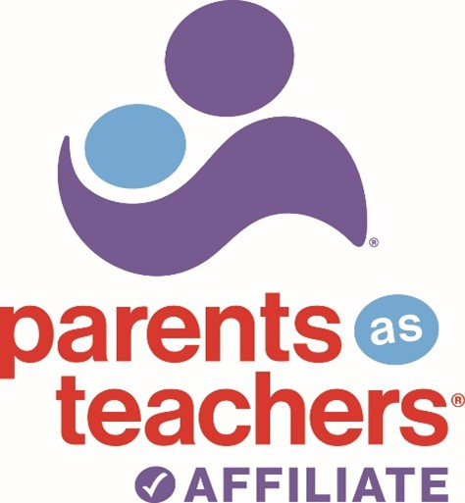

*Serving Albany, Laramie, and Sweetwater counties*

***What is Parents as Teachers?***

Parents as Teachers is an evidence-based, parenting support program for families who are expecting, or have children up to the age of 3. Through home-based services, families are connected with certified Parent Educators to encourage caregiver engagement through the early years of development. Our program believes that parents are their child's first and most important teacher and PAT provides comprehensive support to ensure children are able to thrive, and families have the best opportunity for success.

Parents as Teachers is one of the implementing agencies for the Wyoming Plans of Safe Care (POSC).

|  |
| --- |
| DATE: Referral Source: |
| Is this a POSC Referral: Yes NO |
| Family Name: |
| Address: |
| Phone: |
| Is this a prenatal family? YES NO If yes, what is the due date: |
| Does the family have a child under 3 years of age? YES NO If yes, Birthdate: |
| **Comments:** |

I hereby authorize the above-mentioned provider to release my name to Parents as Teachers who may contact me with information about their services.

**_______________________________________________________________________________________  
Family Signature Date**

Please email this form to [PAT@wycrp.org](mailto:PAT@wycrp.org) Call 307-632-0032 for more information  